**EXPT NO : 5 A python program to implement Multi Layer**

**Perceptron With Backpropagation**

**DATE: 20.9.24**

**AIM:**

To write a python program to implement Multilayer perceptron with backpropagation .

**PROCEDURE:**

Implementing Multilayer perceptron with backpropagation using the Keras dataset involve the following steps:

**Step 1: Import Necessary Libraries**

First, import the libraries that are essential for data manipulation, visualization, and model building.

|  |
| --- |
| # importing modules  import tensorflow as tf  import numpy as np |
|  |
| from tensorflow.keras.models import Sequential |
|  |
| from tensorflow.keras.layers import Flatten |
|  |
| from tensorflow.keras.layers import Dense  from tensorflow.keras.layers import Activation  import matplotlib.pyplot as plt |

**Step 2: Load the Keras Dataset**

The Keras dataset can be loaded.

(x_train, y_train), (x_test, y_test) = tf.keras.datasets.mnist.load_data() **OUTPUT :**



**Step 3: Data Preprocessing**

Ensure the data is clean and ready for modeling. Since the Iris dataset is clean, minimal preprocessing is needed.

|  |
| --- |
| # Cast the records into float values |
| x_train = x_train.astype('float32') |
| x_test = x_test.astype('float32') |
|  |
| # normalize image pixel values by dividing |
| # by 255 |
| gray_scale = 255 |
| x_train /= gray_scale |
| x_test /= gray_scale |
|  |
| print("Feature matrix:", x_train.shape) |
| print("Target matrix:", x_test.shape) |
| print("Feature matrix:", y_train.shape) |
| print("Target matrix:", y_test.shape) |
|  |

**OUTPUT :**

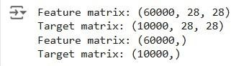

**Step 4 : Train a Model**

|  |
| --- |
| **model = Sequential([**    **# reshape 28 row * 28 column data to 28*28 rows**  **Flatten(input_shape=(28, 28)),** |
|  |
| **# dense layer 1**  **Dense(256, activation='sigmoid'),**    **# dense layer 2**  **Dense(128, activation='sigmoid'),** |
|  |
| **# output layer**  **Dense(10, activation='sigmoid'),**  **])** |

**OUTPUT:**



**Step 5 : Make Predictions**

Use the model to make predictions based on the independent variable.

|  |
| --- |
| model.compile(optimizer='adam', |
|  |
| loss='sparse_categorical_crossentropy', metrics=['accuracy'])  model.fit(x_train, y_train, epochs=10,  batch_size=2000,  validation_split=0.2) |

**OUTPUT:**

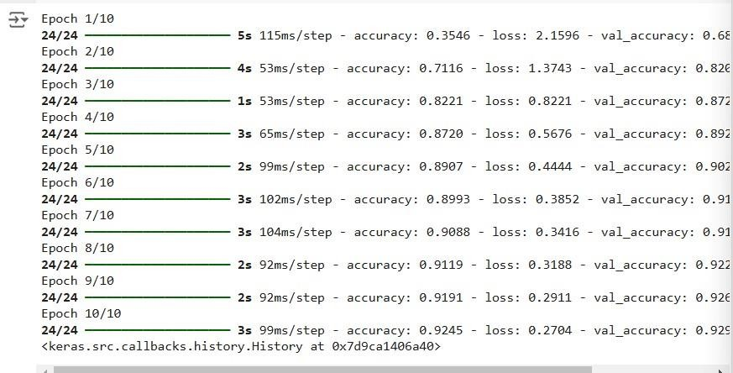

**Step 6 : Evaluate the Model**

Evaluate the model performance.

|  |
| --- |
| results = model.evaluate(x_test, y_test, verbose = 0) |
|  |
| print('test loss, test acc:', results) |
| fig, ax = plt.subplots(10, 10) |
|  |
| k = 0 |
|  |
| for i in range(10): |
|  |
| for j in range(10):  ax[i][j].imshow(x_train[k].reshape(28, 28),  aspect='auto')  k += 1 plt.show() |

**OUTPUT :**



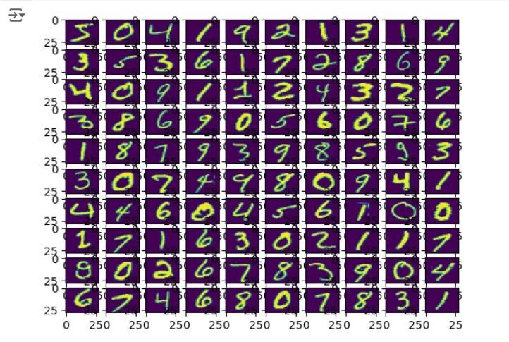

**RESULT:**

This step-by-step process will help us to implement MultiLayer Perceptron with

Backpropagation models using the Keras dataset and analyze their performance.